Spring Term  2025 - 2026  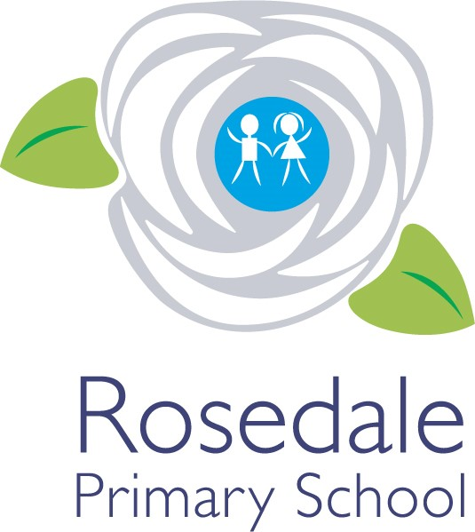  Year 3  Teacher:  Miss Parr  The following information has been provided by the class teacher. It provides an outline of the content of this term’s curriculum. | How you can help  Children  - Read at home every day and get an adult to listen to you at least three times a week – make sure this is logged on ‘Learning With Parents’.  - Practice your times tables on timestables.co.uk or TTRS  - Follow the school code of learning.  - Learn your weekly spellings for the test on Friday  Parents  - Ensure your child attends school every day.  - Listen to them read at least three times a week and record this on ‘Learning With Parents’ to confirm they have done so.  - Make sure that children come to school in PE kits on PE days.  - Provide them with a bottle of (still) water for the day – a sports cap is preferred to avoid spillages  - Encourage positive behaviour at school.  Communication  Please inform school before 9am of your child’s absence. A team of staff are available daily on your child’s door to take messages to be passed on.  Appointments to see your class teacher can be arranged by the school office (if required outside of parents evening).  Mrs Baker: EYFS Phase leader  Ms Adams: KS1 Phase Leader DDSL  Miss Hewitt : KS2 Phase Leader  Mrs Bewick: Pastoral Manager/Designated Safeguarding Lead(DSL)  Appointments with Mrs Denovan (Head of School) or  Ms Adams (Vice Principal) can be made by the school office. | General information  School Day:  - The classroom door opens at 8:45 and closes at 8:50.  - Home time is at 3:15.  PE: Monday and Thursday  Important Dates  - w/c Monday 9th February – Children’s Mental Health Week  - Tuesday 10th February – E-Safety Day  - Friday 13th February – INSET Day  - Wednesday 25th February – Parents Evening  - w/c Monday 2nd March – World Book Week  - Tuesday 3rd March – Cross Country (children to be selected)  - w/c Monday 9th March – Science Week  - Tuesday 10th March – ELP Festival of Sport (children to be selected)
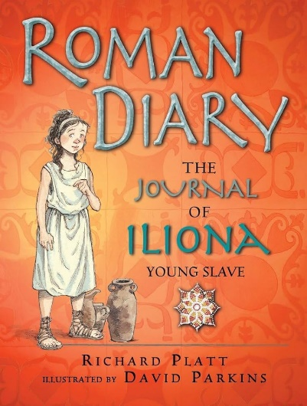
English-
Our class books are ‘Escape from Pompei’ and ‘The Journal of Iliona’ ‘
We will be writing:
- A non-chronological report
- A diary entry
- A story based on the text
- We will be perfecting our handwriting daily through Martin Harvey’s Handwriting Scheme.

Computing – Teach Computing
Creating media – Stop Frame Animation
Programming – Sequencing Sounds
DT (CUSP) Food
We will be making a healthy 3 course meal and serving it to some special guests!
Spring Term
Overview
Music – Recorders and Charanga
We will be learning to play the recorder this year, we will also be singing and learning songs for a summer performance

Maths (White Rose) –
Our focus this term will be on the following units:
- Multiplication and Division
- Length and perimeter
- Times Tables (throughout the year)

Art Painting
We will be exploring colour and brush skills. We will be looking at Artist Kehinde Wiley. Our final piece will be to paint a picture of a tree with a striking background.

Science – Light
Children will:
- Recognise that they need light in order to see things and that dark is the absence of light
- Notice that light is reflected from surface.
- Recognise that light from the sun can be dangerous.
- Recognise that shadows are formed when the light from a light source is blocked by an opaque object.
History – How did the Romans Change Britain?
- How did the Roman Empire begin?
- Why did they invade Britain?
- How did the Roman invasion change Britain?
- What was the impact of the Roman Empire on Britain?

PE – Your PE
- Invasion Games
- Gymnastics
PSHE – Jigsaw
Dreams & Goals
Healthy Me

