Spring Term  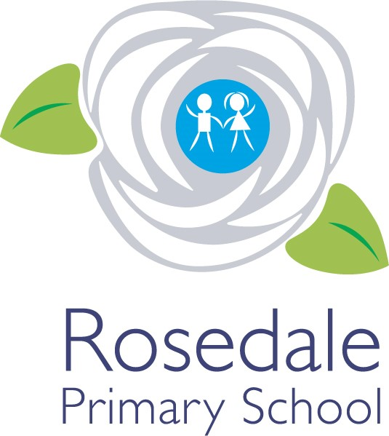  2025 - 2026  Year 4  Teacher:  Miss Pearson  The following information has been provided by the class teacher. It provides an outline of the content of this term’s curriculum. | How you can help  Children  - Read at home every day and get an adult to listen to you at least three times a week – make sure this is logged on ‘Learning With Parents’.  - Listen to the feedback from your teacher and work on trying to make the improvements they suggest.  - Follow the school code of learning.  Parents  - Ensure your child attends school every day.  - Listen to them read at least three times a week and record this on ‘Learning With Parents’ to confirm they have done so.  - Make sure that children come to school in PE kits on PE days.  - Provide them with a bottle of water for the day.  - Encourage positive behaviour at school.  Communication  Please inform school before 9am of your child’s absence. A team of staff are available daily on your child’s door to take messages to be passed on.  Appointments to see your class teacher can be arranged by the school office (if required outside of parents evening).  Mrs Baker: EYFS Phase leader  Ms Adams: KS1 Phase Leader  Miss Hewitt: KS2 Phase Leader  Mrs Bewick: Pastoral Manager/Designated Safeguarding Lead  Appointments with Mrs Denovan (Head of School) or Ms Adams (Vice Principal) can be made by the school office. | General information  School Day:  - The classroom door opens at 8:45 and closes at 9:00.  - Home time is at 3:15.  PE:  Tuesday and Thursday  Ukulele:  Wednesday  Important Dates  - Wednesday 14th January –  KS2 Family Learning 8:45-9:30am
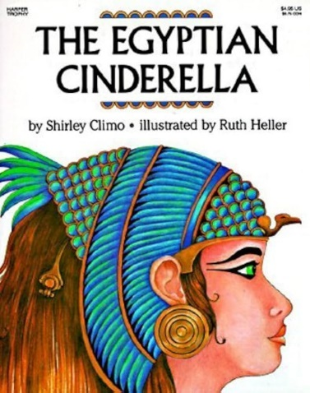
,
History – Our Topic this term is Ancient Egyptians
Children will:
- be introduced to the leadership of some of the most significant Pharaohs as the rulers of Ancient Egypt.
- How ancient Egyptian people believed Pharaohs were divine; gods on earth.
- How the Ancient Egyptians built such an empire and strong social/economic infrastructure.
DT (CUSP) Food and Nutrition
Food and Nutrition
- Children will know that processed foods have many added ingredients
- Make, roll and shape bread dough and Make a soup
RE – Jigsaw RE
- Spring 1 - Judaism-How do Jewish beliefs, teachings and stories impact on daily life?

Maths (White Rose) - Our focus this term will be on the following units:
- Multiplication and division
- Length and perimeter
- Fractions
- Decimals

Art (CUSP) Painting
- How can abstract art be used as opposed to realistic art to express feelings?
English - Our class book is ‘Egyptian Cinderella’ written by Shirley Climo
We will be writing:
- A story narrative
- We will be perfecting our handwriting through Martin Harvey’s Handwriting Scheme.
- We will using our reading lessons to support us in understanding our class book and to delve deeper into our Ancient Egypt topic.

PSHE – Jigsaw
- Spring 1- Dreams and goals
- Spring 2- Healthy Me
Music – Ukulele
- The children will be learning to play the Ukulele this year.
- We hope to set a date when the children can perform for you.
Science – Animals Including Humans (Teeth and Digestion)
Children will learn:
- What teeth do humans have? What do they do?
- How do our teeth and mouth help with digestion? What’s the process?
- Can teeth tell us what animals eat?
Sound –
Children will learn:
- What sound is?
- How sound travels?
- What is the pitch and loudness of sound?
PE – Your PE
- Gymnastics
- Health and Fitness
Computing – Teach Computing
- Programming A – Repetition in shapes

Geography – Our Topic this term is Ancient Egyptians
Children will know:
- Where Egypt is on map.
- The location of the River Nile.
- Geographical features - Human – economic activity, trade, distribution. Physical - River, biomes and vegetation belt.
- Europe. Italy, volcanoes, Pompeii.
Spring Term
Overview

