Spring Term  2025 - 2026  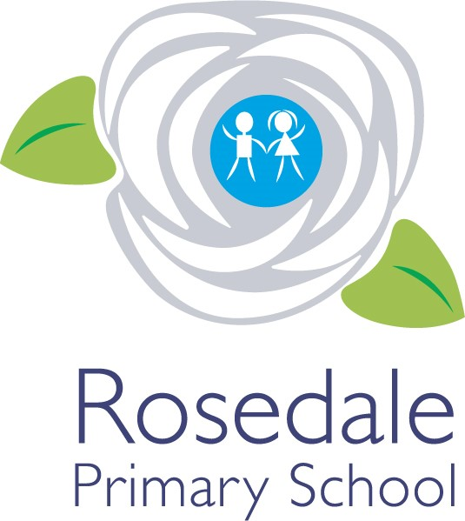  Year 2  Teacher:  Miss Jones  The following information has been provided by the class teacher. It provides an outline of the content of this term’s curriculum. | How you can help  Children  - Read at home every day and get an adult to listen to you at least three times a week – make sure this is logged on ‘Learning With Parents’.  - Listen to the feedback from your teacher and work on trying to make the improvements they suggest.  - Follow the school code of learning.  Parents  - Ensure your child attends school every day.  - Listen to them read at least three times a week and record this on ‘Learning With Parents’ to confirm they have done so.  - Make sure that children come to school in PE kits on PE days, which are Monday and Wednesday.  - Provide them with a bottle of water for the day.  - Encourage positive behaviour at school.  Communication  Please inform school before 9am of your child’s absence. A team of staff are available daily on your child’s door to take messages to be passed on.  Appointments to see your class teacher can be arranged by the school office (if required outside of parents evening).  Mrs Baker: EYFS Phase leader  Ms Adams: KS1 Phase Leader  Miss Parr: LKS2 Phase Leader  Miss Hewitt: UKS2 Phase Leader  Mrs Bewick: Pastoral Manager/Designated Safeguarding Lead  Appointments with Mrs Denovan (Head of School) or Ms Adams (Vice Principal) can be made by the school office. | General information  School Day:  - The classroom door opens at 8:40 and closes at 8:50.  - Home time is at 3:10.  PE:  - Monday and Wednesday  Important Dates  - 20th January – Multi Skill Festival  - W/C 9th February – Children’s Mental Health Week  - 13th February – INSET Day  - W/C 23rd February – Careers Week  - 5th March – World Book Day.  - 20th March – Conisbrough Castle Trip.  - 26th March – Spring Crafts  - 27th March – Learning Showcase
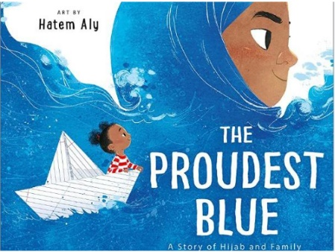
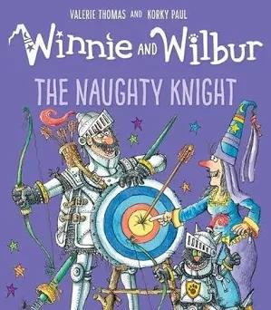
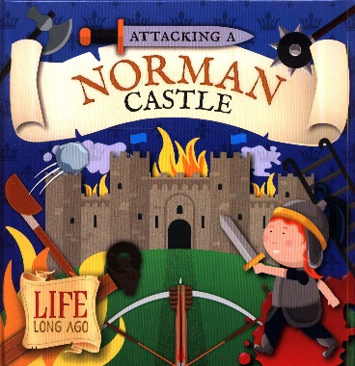
Spring Term
Overview
History – Who were the Normans?
- Trip to Conisbrough castle.
- Why did they build castles?
- What was the Battle of Hastings?
- Famous Normans.
DT (CUSP) –
- Making puppets
Music – Charanga
- Rhythm, pitch and tempo
English- Our class books are ‘Attacking a Norman Castle’ by Robin Twiddy, ‘The Proudest Blue’ by Ibtihaj Muhammed and The Naughty Knight by Valeire Thomas.
We will be writing:
- Information reports based on Norman Castles.
- Narratives inspired by our class books.
- Poems inspired by our class books.
Geography – Locality Study about Conisbrough.
Children will know:
- The importance of Conisbrough.
- The features/area of Conisbrough.
- As well as broadening our knowledge of using a map and a compass.
PE – Your PE
- Target Games
- Gymnastics
Maths (White Rose) - Our focus this term will be on the following units:
- Addition and Subtraction
- Multiplication and division

PSHE – Jigsaw
- Spring 1 – Dreams and Goals.
- Spring 2 – Healthy Me.
RE – Jigsaw RE
- Spring 1 – Islam – Who is God to Muslims?
- Spring 2 – Christianity - How important is it to Christians that Jesus came back to life after his crucifixion?
Art (CUSP) -
- Drawing a Norman Castle using different mediums.
Computing – Teach Computing
- Programming a Robot.
- Programming Quizzes.
Science –
Living Things and their Habitats
- Is something alive, dead or was never alive?
- What is a habitat?
- Minibeasts
- Food Chains

Animals including Humans
- Life Cycles
- How do animals survive?
- Healthy Living

