
Newsletter

November 2025


Dear Parents and Carers,
Happy New Year and welcome back to school! We hope you all enjoyed a wonderful holiday filled with fun, rest, and special moments with family and friends.
It has been fantastic to see the children return with big smiles, happy chatter, and lots of excitement for the year ahead. The start of a new year is a perfect time for fresh starts, new friendships, and exciting learning adventures. It was great to see so many of you join us for our attendance assemblies and Family Learning events last week – it was a lovely way to begin the new term and look ahead to the new topics the pupils will be focusing on.
This term promises to be an exciting one, with lots of engaging learning experiences, out of school visits and competitions, special events, and opportunities for the children to develop their confidence, creativity, and independence. We look forward to working closely with you to support every child as they continue their learning journey.
Thank you, as always, for your continued support and partnership. We wish all our families a happy, healthy, and successful year ahead.
Yours Sincerely
Mrs A Denovan

Attendance
We kindly remind parents and guardians that all term-time holidays must be submitted using the official holiday request form before any absence. Taking children out of school during term time without prior approval can lead to unauthorised absences and may result in fines in line with local education authority guidelines. Please plan ahead and ensure forms are submitted in advance to help us support your child’s learning and attendance.

Our next Attendance Challenge due to begin on 26th January. As a reminder if your child is not well enough for school please ring the school office to inform them of your child’s absence each day that they are absent.
The school gates are opened each day at 8.35am. Pupils should make their way into school via their classrooms doors by 8.45am when the classroom doors will close. Lates last term accounted for 0.64% of our overall attendance.
Registers close at 9am and any pupils arriving after 9.00am will receive a late mark. If a student is late by just a few minutes each day, it adds up quickly for example:

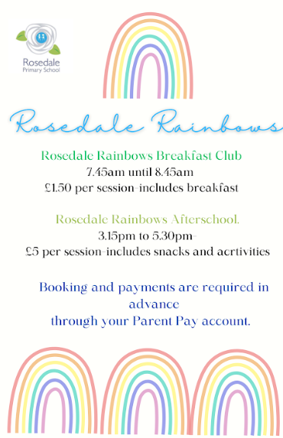
Breakfast and After School Club
We still have a number of places available at our After School provision – Rosedale Rainbows. The session runs from 3.15 – 5.30pm and includes a light snack as well as various activities for the children to do.
A reminder that all breakfast and after school bookings must be booked one week in advance via Parent APP - this is to ensure that correct staffing ratios and provision can be put in place. As our breakfast club is increasingly full, any missed payments or failure to book in advance may result in pupils being unable to attend. For any questions regarding wrap around provision please contact the school office.


Arbor Communication
We are pleased to announce that Arbour communication is now live at Rosedale and all communication will be sent via the APP. This will streamline our communication processes. If you have not yet signed up to your Arbour account, please call into the school office so that we can support you in this.
Important Dates
February
9th - 15th - Children’s Mental Health Week
10th - E -Safety Day
13th – INSET DAY
16th - HALF TERM
23rd – INSET Day
24th - 27th Careers Week
25th - Spring Parents Evening: 3.30pm - 6.30pm
March
2nd- 6th Book Week (5th World Book Day)
9th - 13th Science week
16th - Exceed Dance Festival
18th March EYFS Learning showcase
20th - Red Nose Day
23rd - 27th Learning Showcases
Yr1 - 26th: 2pm
Yr2 - 27th: 9am
Yr3 - 23rd 2:30pm
Yr4 - 27th 2:30pm
Yr5 - 25th 2:30pm
Yr6 - 24th 2:30pm
26th - EYFS Spring Welly Walk: 9am
- KS1 Spring Crafts 2pm
- KS2 Spring Disco 3.15 - 4.30pm

